Lab 6: Styling with CSS

Nội dung
6.1 Prepare 2
6.2 Embedded style 2
6.3 External style 2
6.4 Text properties 3

6.1 Prepare
Create Lab7-1 directory in the lab exercise project.

Embedded style
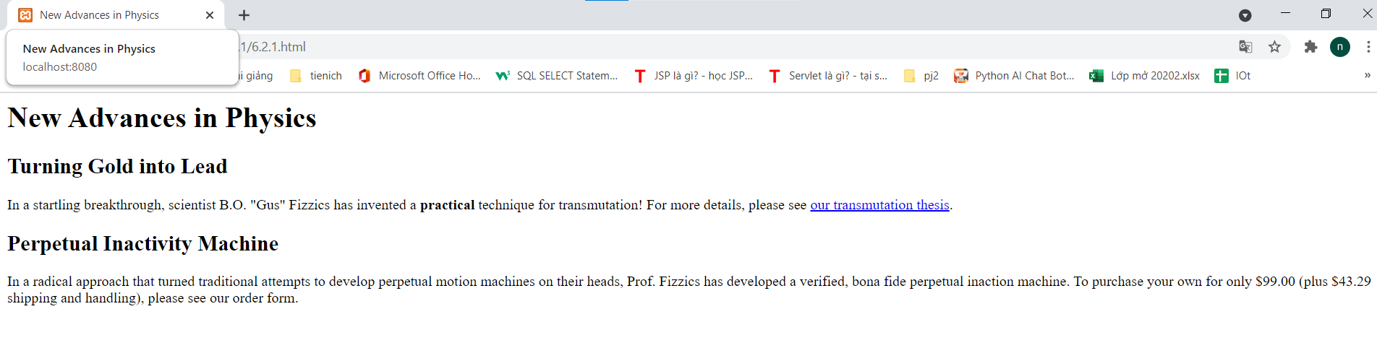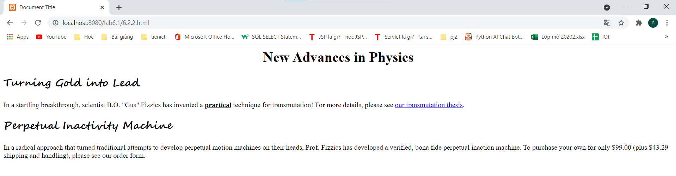

External style
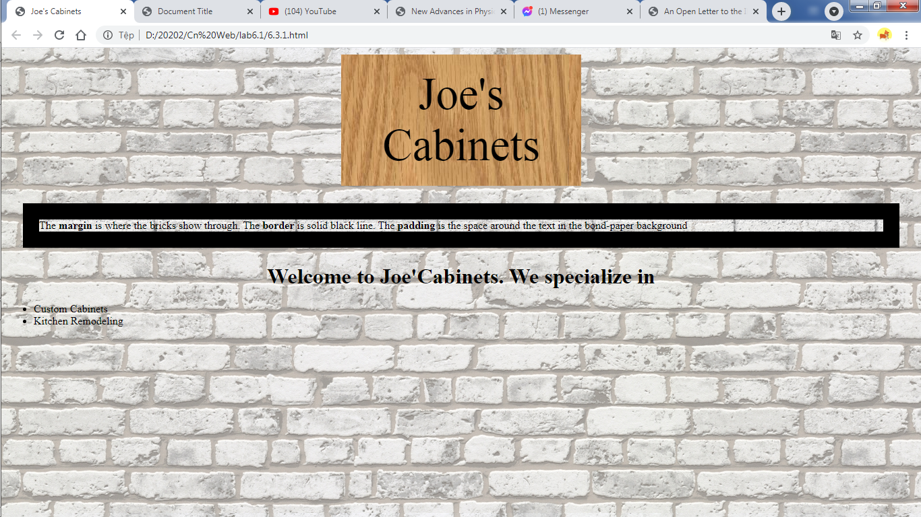

Text properties
